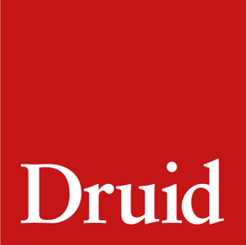
Druid Community and Education

Once Upon a Bridge (2022)

Writing Prompt 2
From the News to the Stage
Find a news story that inspires you. Do your research and write a scene or short play in response to this story. Take artistic licence, change the names, fictionalise the events.
Consider the following:

Format
Do the characters talk in monologue, directly to the audience (like in Once Upon a Bridge) or do the characters talk to one other, in dialogue?

Characters
Who will you include in your story?
Scenes
What parts of the story would you like to dramatise?
Timeline
At what point do we join the story? What part of the story is most interesting for the audience to enter the world of the characters? Do you start at the very beginning of the news story? Do you start in the middle? Do you start at the end?
Name: _______________________

NAME

RESPONSE TITLE

Please type your response to Writing Prompt 2 into the space below. The text box will expand as you type.

